11.50: a) The tension in the string is 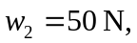and the horizontal force on the bar must balance the horizontal component of the force that the string exerts on the bar, and is equal to 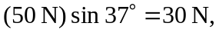 to the left in the figure. The vertical force must be
d) Taking torques about (and measuring the distance from) the left end, 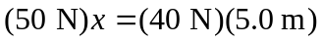, so 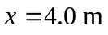, where only the vertical components of the forces exert torques.

